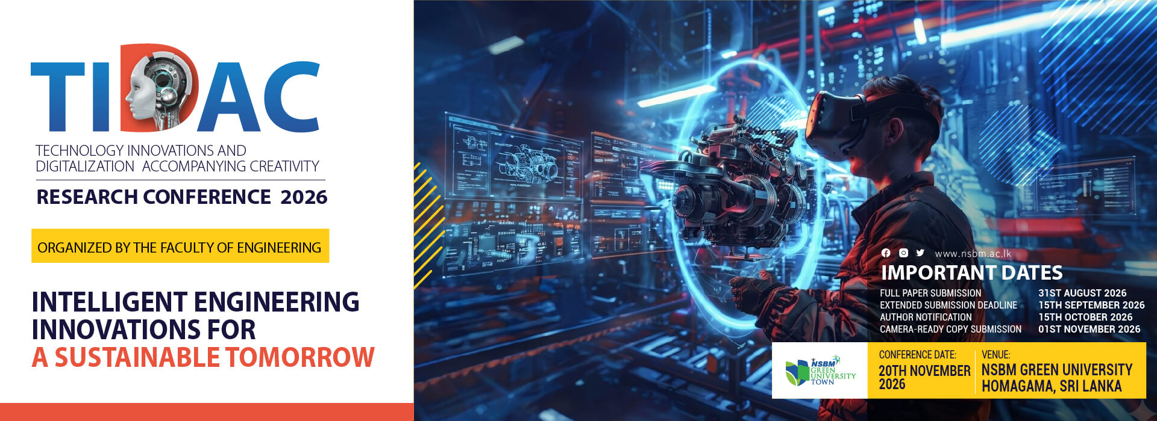
Call for Papers & Submission Guidelines
Researchers, academics, industry professionals, and postgraduate students are invited to submit original, unpublished research to the Technology, Innovation, Design, and Applied Computing (TIDAC 2026) international conference.

1. General Requirements
- Originality: Manuscripts must represent original, high-quality research that has not been previously published or currently under review elsewhere.
- Language: The official language of the conference is English.
- Review Process: All submissions undergo a rigorous double-blind peer review by subject matter experts based on relevance, novelty, methodology, and technical quality.
- Plagiarism Policy: Manuscripts are screened using plagiarism detection tools (such as Turnitin). Submissions exceeding 15–20% similarity or containing unreferenced copied content will be rejected without review.
2. Submission Tracks
TIDAC 2026 invites contributions across interdisciplinary tracks, including but not limited to:
- Track 1: Intelligent Systems, Robotics, and Computer Systems
- Track 2: Data Science, IoT, and Communication Engineering
- Track 3: Artificial Intelligence, Emerging Technologies, and Computer Vision
- Track 4: Electrical, Electronics, and Sustainable Energy Engineering
- Track 5: Mechanical, Mechatronic, and Industrial Engineering
- Track 6: Sustainable Built Environment, Civil and Environmental Engineering
3. Submission Stages & Formatting
Stage A: Initial Submission (For Double-Blind Review)
- Blind Review Template: Authors must use the official TIDAC 2026 Blind Review Template (MS Word format).
- Anonymity: Do NOT include author names, affiliations, email addresses, or self-identifying references anywhere within the initial submission file.
- Declaration Form: Complete author names, institutional affiliations, and contact details must be provided separately via the online submission portal/declaration form.
- File Format: Upload in .doc / .docx format as instructed on the portal.
- Submission: Authors should submit their full paper to the conference through the CMT portal.
Technical Formatting Standards
- Page Count: 6 pages maximum.
- Typography: Follow standard single-line spacing, specific heading hierarchy, and default section styles provided in the template.
- Required Sections: Title, Abstract, Keywords, Introduction, Methodology, Results & Discussion, Conclusion, and References.
- Figures & Tables: Embed images directly into the document. Place table titles above tables and figure captions below figures (e.g., Fig. 1. System architecture).
- Equations: Use Microsoft Equation Editor or MathType. Number equations consecutively in parentheses flush right, e.g., (1).
- Citation Style: Strictly follow the IEEE reference format (e.g., [1], [2]).
Stage B: Camera-Ready Submission (Post-Acceptance)
- Review comments and final Submission: The accepted papers, along with the reviewers’ comments, will be sent to the corresponding author for revision and resubmission (if necessary). The resubmission should be done to the CMT online platform.
- Author Details: Re-insert author names, affiliations, and official email addresses into the final camera-ready copy.
- Reviewer Comments: Incorporate all mandatory revisions requested by reviewers.
- Copyright Form: Submit a signed Copyright Transfer Form alongside the camera-ready version.

4. Important Dates (Tentative Schedule)
Milestone | Date
Call for Papers Opens | 20th July 2026
Full Paper Submission Deadline | 31st August 2026
Notification of Acceptance | 15th October 2026
Camera-Ready Copy & Registration Deadline | 01st November 2026
Conference Dates | 20th November 2026
5. How to Submit
1. Download the official TIDAC 2026 Paper Template from the official conference portal.
2. Create an account on the CMT Online Submission Portal.
3. Upload your anonymized manuscript in .doc / .docx format.
4. Fill in all author metadata during the portal submission process.

Registration Requirement: At least one author of each accepted paper must register for the conference and present the paper for it to be included in the official conference proceedings.

